**Assignment 1: Biometric System Evaluation ROC**

**Question 1: Genuine and Impostor Score Distributions**

**Description**

The goal of this task is to analyze the similarity scores between images in the Celebrities in Frontal-Profile Wild (CPFW) dataset. We will extract genuine and impostor scores from the similarity matrix and visualize their distributions.

**1. Extract Genuine and Impostor Scores**

* **Genuine Scores**: These scores are obtained when comparing images of the same subject. Since each subject has multiple images, we extract scores where both images belong to the same subject.
* 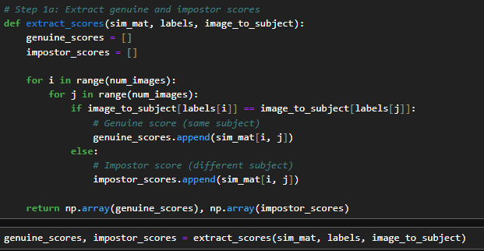**Impostor Scores**: These scores are calculated when images from different subjects are compared. This involves cross-comparing each subject’s images with all other subjects’ images.

Figure 1 - Imposter and Genuine Score

These Scores were also saved in **genuine_score.txt** and **impostor_scores_file.txt** files respectively.

**2. Plot the Score Distributions**

* **Histogram of Genuine and Impostor Scores**: This shows the raw frequency of similarity scores for both genuine and impostor matches.

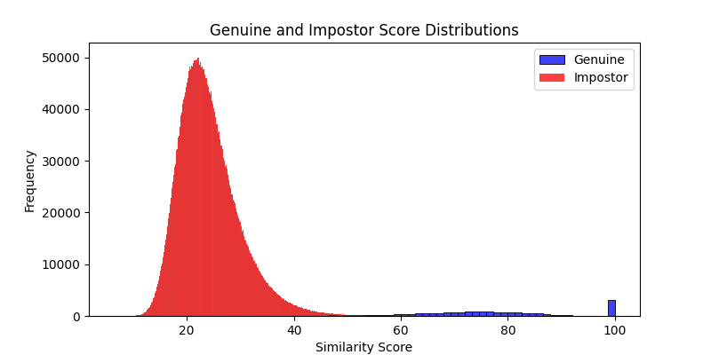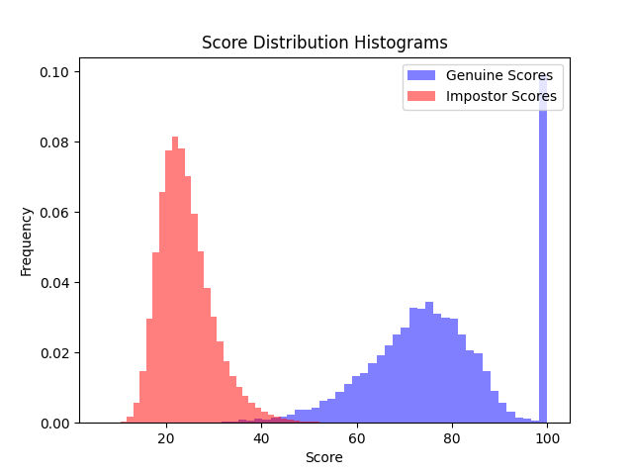

Figure 2 - histograms of Genuine and Impostor scores

* 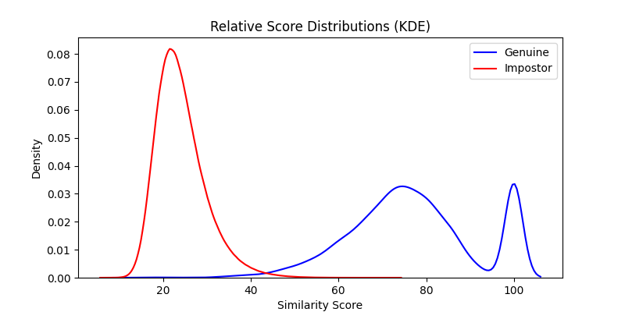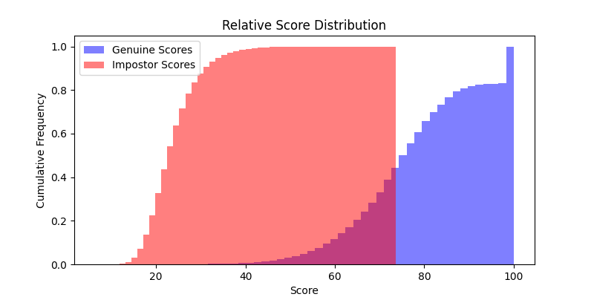**KDE Plot for Relative Score Distribution**: The Kernel Density Estimation (KDE) plot shows the smooth distribution (probability density) of the similarity scores, giving insights into how the scores are distributed.

Figure 3 - Relative score distribution

**Question 2: D-prime Calculation**

**Description**

The **D-prime (d’)** is a statistic used to quantify the separation between two distributions—in this case, the genuine and impostor score distributions. It measures how well-separated these two score distributions are**.** The formula for **D-prime (d’)** is

**Where:**

* is the mean of the genuine scores.
* is the mean of the impostor scores.
* is the standard deviation of the genuine scores.
* is the standard deviation of the impostor scores.

**D-prime Interpretation**

* A higher **d’** value indicates better separation between the two distributions.
* A **d’** of 0 means that the two distributions overlap perfectly, and it is impossible to distinguish between them.
* Larger **d’** values indicate better separability.

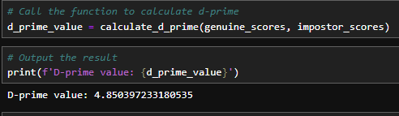

Figure 4 - D Prime Value

**Question 3: Receiver Operating Characteristic (ROC) Curve**

**Description**

The **ROC Curve** is a graphical plot used to illustrate the diagnostic ability of a binary classifier as its discrimination threshold is varied. It plots the **True Positive Rate (TPR)** against the **False Positive Rate (FPR)** for different threshold values.

**Steps for ROC Curve Calculation**

**3a. Calculate TPR and FPR for Varying Thresholds**

* **True Positive Rate (TPR)**: The proportion of genuine scores correctly identified as genuine
* **False Positive Rate (FPR)**: The proportion of impostor scores incorrectly identified as genuine.



Figure 5 - Calculate TPR and FPR

**3b. Plot the ROC Curve and Compute AUC**

* **AUC (Area Under the Curve)**: The AUC gives an aggregate measure of performance across all possible classification thresholds. An AUC of 1.0 represents a perfect classifier, while an AUC of 0.5 represents a random classifier.
* **ROC Curve Calculation**:
  + The **roc_curve()** function from **sklearn.metrics** computes the **False Positive Rate (FPR)** and **True Positive Rate (TPR)** for a variety of threshold values.

1. **AUC Calculation**:
   * The **auc()** function calculates the area under the ROC curve. This value ranges from 0.5 **(random guessing)** to 1.**0 (perfect classification).**

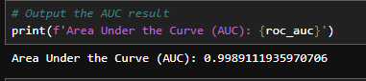

Figure 6 - Output of AUC Result

1. **ROC Curve Plotting**:
   * We plot the ROC curve using matplotlib. The FPR is plotted on the x-axis, and TPR on the y-axis. The diagonal line represents random guessing.
   * The ROC curve shows how well the system separates genuine from impostor scores.

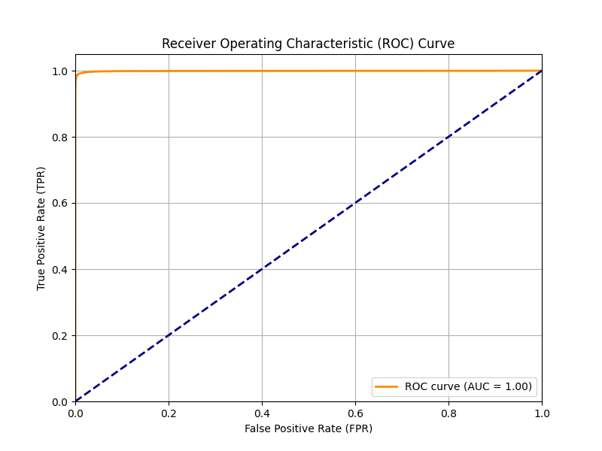

Figure 7 - ROC Curve

**Question 4: Cumulative Match Characteristic (CMC) Curve**

**Description**

The **Cumulative Match Characteristic (CMC) Curve** is used to evaluate the rank-based identification performance of a biometric system. In this case, the CMC curve shows the probability that the correct identity is within the top-k ranks of the sorted similarity scores.

The CMC curve is particularly useful for evaluating identification systems **(as opposed to verification systems, which the ROC curve is for).**

**Steps to Generate a CMC Curve**

**1. Rank Calculation**

* For each probe (test) image, compare it to all the gallery images (reference images).
* Sort the gallery images by their similarity scores to the probe.
* Find the rank at which the true match (genuine score) appears for each probe image.

**2. CMC Curve Calculation**

* For each rank (k), calculate the percentage of probe images for which the correct identity is in the top-k matches.
* Plot this cumulative percentage for increasing values of (k).

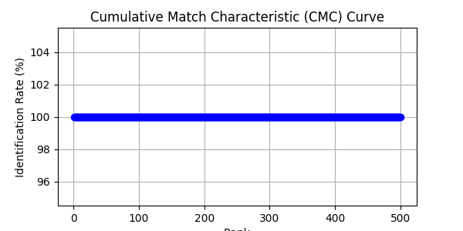

Figure 8 - CMC Curve

**Key Concepts**

* **Rank-1 Identification Rate**: The percentage of times the correct identity is the top-ranked match (perfect match).
* **Rank-k Identification Rate**: The percentage of times the correct identity is found within the top-k matches.

**Step 5: False Match Rate (FMR) and False Non-Match Rate (FNMR) Curves**

**Definitions:**

1. **False Match Rate (FMR)**: The rate at which impostor pairs (non-matching subjects) are incorrectly classified as matches (genuine
   * This increases as the threshold for a match becomes more lenient.
2. **False Non-Match Rate (FNMR)**: The rate at which genuine pairs (matching subjects) are incorrectly classified as non-matches (impostors).
   * This increases as the threshold for a match becomes more strict.

**Steps:**

1. **Compute FMR and FNMR** for a series of thresholds.
2. **Plot the curves** on the same graph.
3. **Identify the operating threshold** that minimizes the absolute difference between FMR and FNMR.

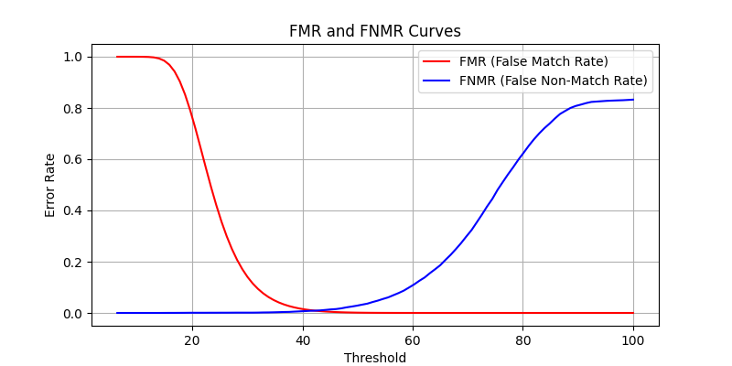

Figure 9 - FMR and FNMR Curve

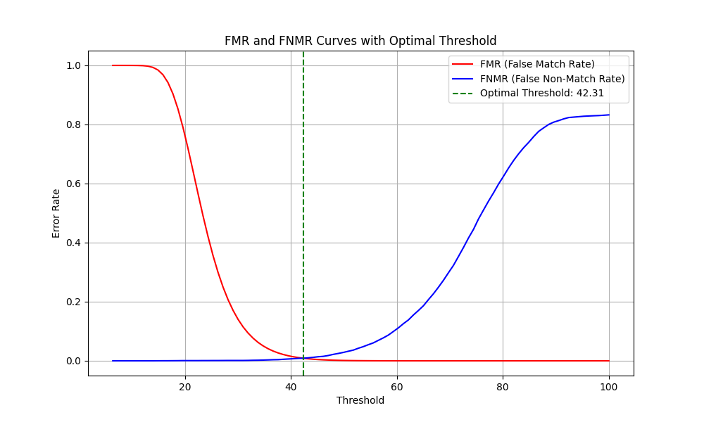

Figure 10 - FMR curve with optimal threshold

**Key Concepts:**

* **FMR**: The error rate for falsely identifying impostor matches as genuine matches.
* **FNMR**: The error rate for falsely identifying genuine matches as impostor matches.
* **Optimal Threshold**: The threshold that minimizes the difference between FMR and FNMR, often used as the operating point in biometric systems.